Project Synopsis

Project Title:

Chiti Code – A Coding-Focused AI Assistant for Android
Domain: Mobile Application Development and Conversational Artificial Intelligence
Platform: Android Studio using Kotlin and Jetpack Compose
Database: Room Database backed by SQLite for local conversation storage
AI Service: OpenRouter Chat Completions using the OpenAI Luna model (openai/gpt-5.6-luna)

1. Introduction
Chiti Code is a native Android application designed to provide focused assistance for programming and software-development tasks. The application allows a developer or student to ask coding questions, receive an incremental response from an AI model, and return to earlier discussions through a locally stored conversation history. Its primary goal is to make coding support accessible in a simple mobile interface without combining it with unrelated general-purpose features.
The application follows a text-only conversational model. A coding-focused system prompt guides the remote AI service to answer questions about programming languages, algorithms, debugging, APIs, databases, testing, and developer tools. Responses are displayed as they arrive, with Markdown rendering for code blocks and structured explanations. Conversation records are stored on the device through Room, allowing the user to review history without requiring an account or cloud synchronization.

2. Problem Statement
Developers and students often need quick programming guidance while working away from a desktop environment. A useful mobile assistant must do more than send a single request: it should preserve context, provide readable code-oriented output, remain responsive while a long answer is generated, and make previous discussions easy to retrieve. Without these capabilities, users face several practical difficulties:
- Fragmented assistance: General-purpose tools may mix programming answers with unrelated topics, making a coding workflow less focused.
- Delayed feedback: Waiting for a complete response before displaying any output makes the application feel unresponsive during longer generations.
- Loss of context: A stateless question-and-answer screen cannot maintain the recent exchange needed for follow-up debugging or code explanation.
- Poor local continuity: Users may lose access to useful coding discussions when an application does not retain conversations on the device.
- Unreadable technical output: Plain text without Markdown support makes code blocks, tables, links, and structured explanations harder to understand.

3. Objectives
The primary objectives of the Chiti Code project are:
- To provide a mobile-first, coding-focused conversational interface for programming questions.
- To send prompts to the OpenRouter chat-completions service and display AI output incrementally through streaming.
- To preserve conversations and messages locally using a Room database so users can revisit previous discussions.
- To include recent conversation context when constructing a new request, while limiting the history sent to the model.
- To render assistant responses as Markdown so code, tables, links, and structured explanations remain readable.
- To provide clear chat controls for starting a conversation, selecting stored conversations, and deleting history.
- To handle network and coroutine failures through visible Snackbar messages and local crash logging.

4. System Architecture and Modules
Chiti Code uses a layered package structure inside a single Android application module. The presentation layer observes state through Kotlin StateFlow, the repository coordinates local and remote data sources, and the application container provides shared instances of the database, API client, and repository.

A. Presentation Module
- Chat screen: A Jetpack Compose screen containing the model header, welcome suggestions, message list, input area, and sidebar overlay.
- ViewModels: ChatViewModel manages the active conversation, message state, streaming state, and errors; ConversationListViewModel exposes the stored conversation list.
- Reusable components: Chat input, message bubbles, Markdown content, sidebar, theme, and supporting UI components provide a consistent Material 3 experience.

B. Repository and Domain Module
- ChatRepository: Coordinates Room operations, request construction, stream events, message persistence, conversation timestamps, and automatic first-message titles.
- Domain models: Conversation and ChatMessage represent application data independently of the persistence entities.
- Stream events: A sealed event model communicates user-message persistence, assistant-message creation, content deltas, completion, and errors.

C. Local Storage Module
- Room database: ChatDatabase stores ConversationEntity and MessageEntity records in the local SQLite database named chat_database.
- DAOs: ConversationDao and MessageDao provide observable Flow queries and insert, update, and delete operations.

D. Remote AI Module
- OpenRouterApi: Creates an authenticated HTTPS request, sends the selected model and message history, and parses streamed data lines.
- Model configuration: AiModels currently exposes one product model, OpenAI Luna, identified as openai/gpt-5.6-luna.

5. Technical Stack (Tools and Technologies)
- Operating system: Android with a minimum SDK of 26 and target/compile SDK 34.
- Integrated Development Environment: Android Studio with Gradle Kotlin DSL build configuration.
- Programming language: Kotlin with Java 17 source and JVM targets.
- User interface: Jetpack Compose, Compose Material 3, Material icons, and a custom dark theme.
- Architecture: Single-activity UI with an MVVM-style presentation layer, repository coordination, and manual dependency injection through AppContainer.
- Local database: Room 2.6.1 and SQLite, with Kotlin Flow for reactive conversation and message queries.
- AI integration: OpenRouter Chat Completions API using the OpenAI Luna model and an application-provided API key.
- Networking: OkHttp 4.12.0 for HTTPS requests and manually parsed server-sent streaming response lines.
- Serialization: Gson 2.10.1 for request and streamed response JSON conversion.
- Concurrency: Kotlin Coroutines 1.7.3, Dispatchers.IO, Flow, StateFlow, and lifecycle-aware ViewModel scopes.
- Markdown rendering: Markwon 4.6.2 modules for Markdown, tables, HTML, strikethrough, links, and image loading.
- Image loading: Coil integration through the Markdown renderer for images referenced by Markdown content.
- Build and release: Android Gradle Plugin 8.2.2, Kotlin 1.9.22, Compose compiler 1.5.8, release minification/resource shrinking, and GitHub Actions automation.

6. Unique Features of Chiti Code
- Coding-focused behavior: A dedicated system prompt directs the model toward software-development topics and asks it to respond in the language used by the user.
- Live response streaming: The assistant placeholder appears immediately and is updated as individual response fragments arrive from the network.
- Local conversation history: Conversation titles, timestamps, and messages are retained in Room and presented through a date-grouped sidebar.
- Automatic conversation titles: The first user prompt is converted into a short title so a new conversation can be recognized later.
- Readable technical output: Assistant responses are rendered as Markdown, supporting code-oriented explanations and structured content.
- Focused mobile interface: The dark Material 3 interface includes a welcome screen, prompt suggestions, message bubbles, loading feedback, and a compact input area.
- Operational diagnostics: Network and coroutine failures are surfaced to the user and recorded by the app’s local CrashLogger for troubleshooting.

7. Future Scope
- Secure credential management: Move away from embedding a service credential in the client APK by introducing a secure user-managed key flow or a server-side token broker.
- Stream cancellation: Connect the existing stop interaction to the active coroutine and OkHttp call so a user can cancel a long response safely.
- Search and organization: Implement sidebar search, conversation renaming, pinning, filtering, and export of selected coding discussions.
- Accounts and synchronization: Add optional authentication and encrypted cloud synchronization for users who need access across devices.
- Usage awareness: Display token usage, request errors, rate-limit information, and model availability using the existing response metadata structures.
- Engineering quality: Add repository interfaces, dependency injection abstractions, unit tests for prompt/history construction, DAO tests, stream parser tests, and Compose UI tests.
- Accessibility and localization: Move visible strings into resources, standardize error messages, and improve screen-reader, contrast, and large-text support.

Use Case Diagram (Functionality Overview)
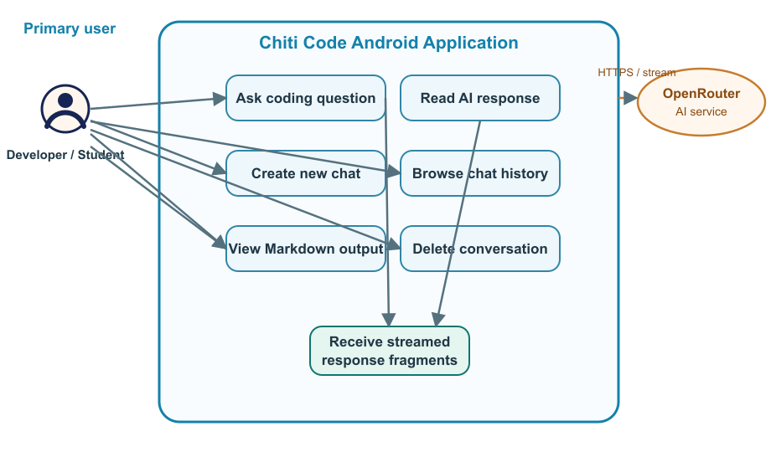
The primary actor is a developer or student. The user enters a coding prompt, reads the streamed response, views Markdown output, and manages locally stored conversations. OpenRouter acts as the external AI service that receives the request and returns response fragments.

Flowchart: Streamed Chat Process (Logic Flow)
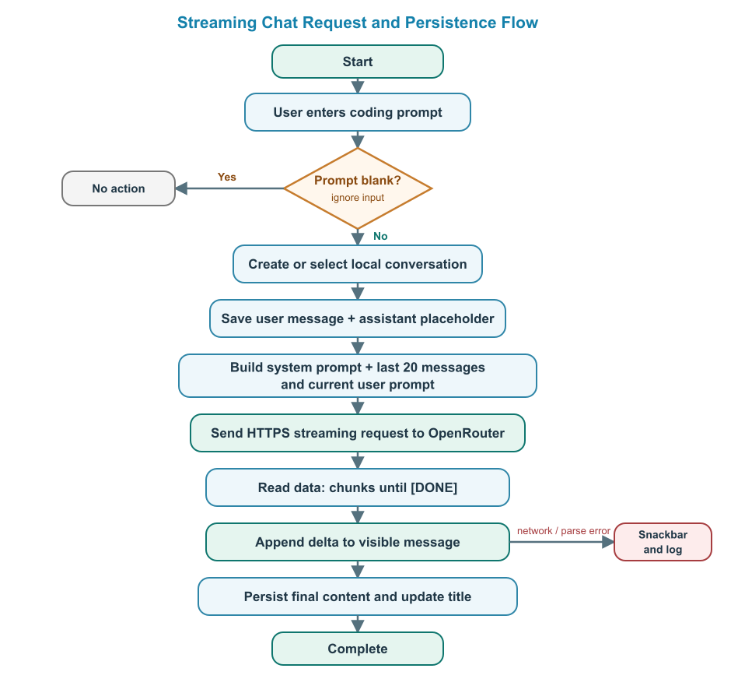
Before the request is sent, the application saves the user message, creates an assistant placeholder, and assembles the system prompt with recent history. Each streamed data chunk updates the visible message until completion or an error occurs.

ER Diagram (Local Database Structure)
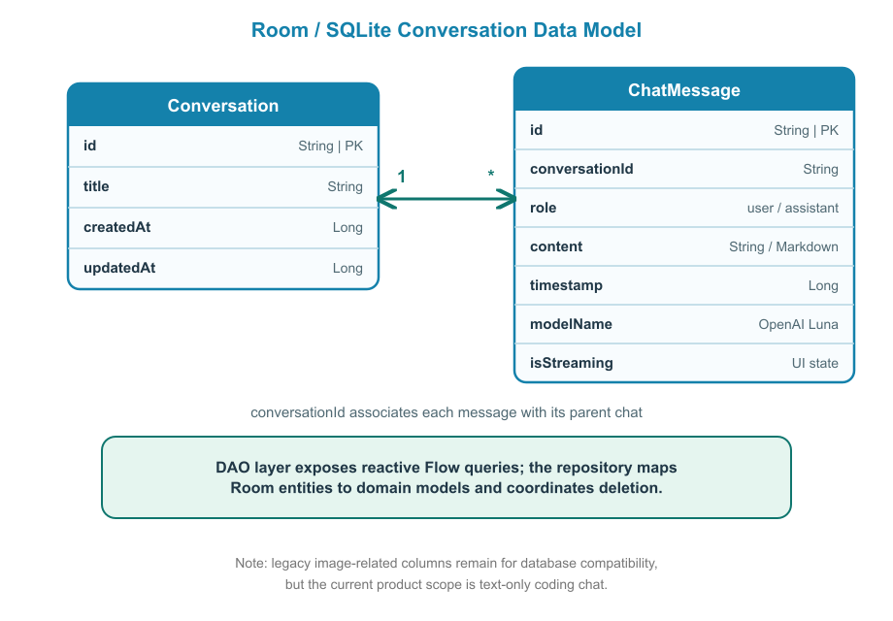
A conversation contains many chat messages. Room exposes this information through DAO queries and Kotlin Flow. The current application uses text-based user and assistant messages; legacy image-related fields remain only for database compatibility and are not part of the active product workflow.

8. Conclusion
Chiti Code provides a focused mobile solution for developers and students who need accessible programming assistance. By combining a Jetpack Compose interface with OpenRouter streaming, the application gives immediate visual feedback while an AI response is generated. The coding-oriented system prompt also establishes a clear product identity and keeps the conversation centered on software development.
The project demonstrates the integration of modern Android development practices: Kotlin-based application code, Compose UI, lifecycle-aware ViewModels, coroutines and Flow, repository-based data coordination, Room persistence, structured JSON communication, and Markdown rendering. Local conversation storage, automatic titles, date-grouped history, and error diagnostics make the prototype practical for repeated use rather than limiting it to one-off queries.
The current implementation intentionally remains text-only and uses a single remote model. It does not include accounts, cloud synchronization, message search, or user-configurable API settings. These boundaries provide a clear foundation for future improvements in security, reliability, accessibility, testing, and multi-device support while preserving the central goal: a simple and responsive coding assistant for Android.

Implementation Summary
- Input: The user enters a programming request through the Compose chat input.
- Processing: The repository builds a coding prompt with recent context and sends it to OpenRouter.
- Output: Streamed AI content is rendered as Markdown and saved locally with the conversation.
- Management: The sidebar lets the user create, select, and delete local conversations.

